**EX NO. 1. NETWORKING COMMANDS**

**Tcpdump:**

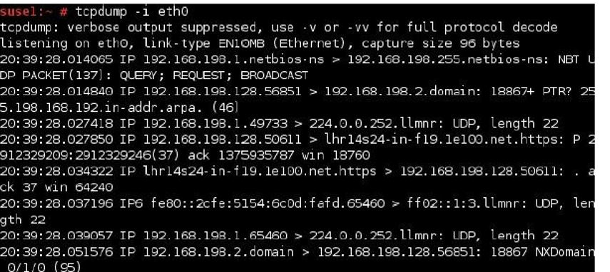tcpdump is a most powerful and widely used command-line packets sniffer or package analyzer tool which is used to capture or filter TCP/IP packets that received or transferred over a network on a specific interface for analysis.

**Netstat:**

Displays active TCP connections, ports on which the computer is listening, Ethernet statistics, IP routing table, IPv4 statistics and IPv6 statistics. It indicates state of a TCP connection. it's a helpful tool in finding problems and determining the amount of traffic on the network as a performance measurement.

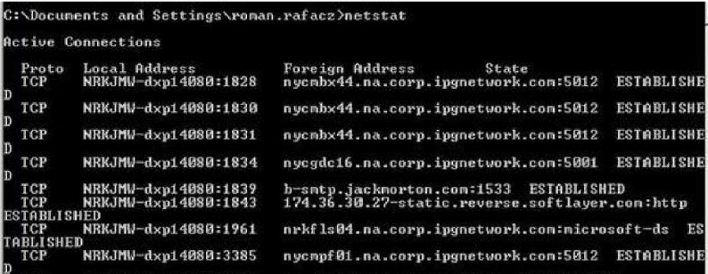

**ifconfig / ipconfig:**

Displays basic current TCP/IP network configuration. It is very useful to troubleshoot networking problems. ipconfig/all is used to provide detailed information such as IP address, subnet mask, MAC address, DNS server, DHCP server, default gateway etc. ipconfig/renew is used to renew a DHCP assigned IP address whereas ipconfig/release is used to discard the assigned DHCP IP address.

**nslookup :**

It provides a command-line utility for querying DNS table of a DNS Server. It returns IP address for the given host name.

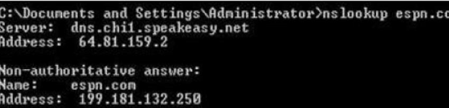

**traceroute / tracert:**

Displays the path taken to a destination by sending ICMP Echo Request messages to the destination with TTL field values. The path displayed is the list of nearest router interfaces taken along each hop in the path between source host and destination.

**Ping:**

Verifies IP-level connectivity to another TCP/IP computer by sending Internet Control Message Protocol (ICMP) Echo Request messages. The receipt of corresponding Echo Reply messages are displayed, along with round-trip times. Ping is the primary TCP/IP command used to troubleshoot connectivity, reachability, and name resolution.

